1. A close-up of a logo

   Description automatically generated
2. 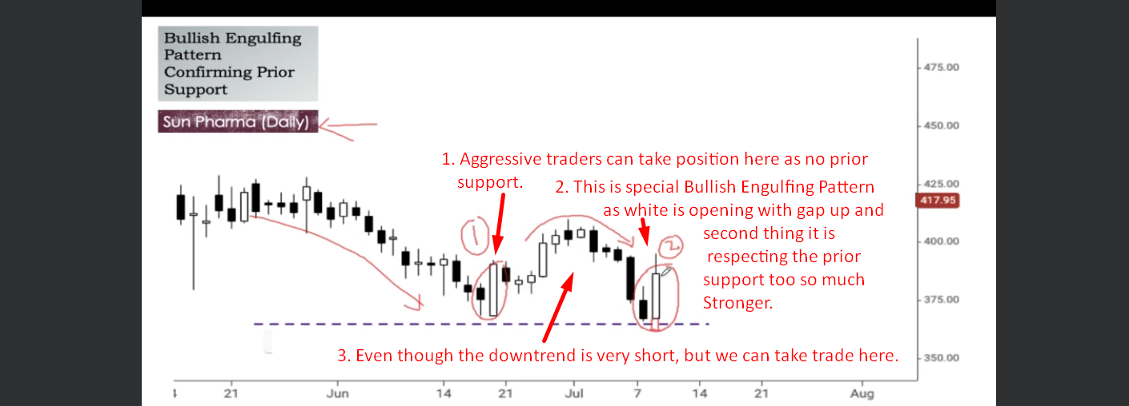
3. A graph of a stock market

   Description automatically generated